**Embed the Power BI report in SharePoint Online**

**Step 1: Generate an embed link**

1. Sign in to Power BI, then in the left navigation pane, click or tap the report name.

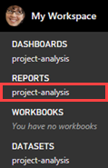

1. Click or tap **File**, then **Embed in SharePoint Online**.

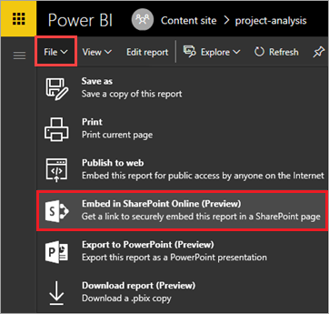

1. Copy the embed link from the dialog box to a file, then click or tap **Close**. We will use the link after we create a SharePoint page.

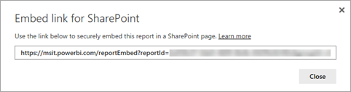

**Step 2: Embed the report**

1. Sign in to SharePoint, then click or tap **Site contents**.

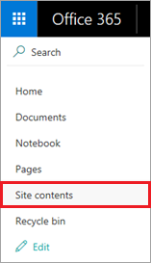

1. You could just include a report on the team home page, but we'll show you how to create a separate page for it also. Click or tap **New**, then **Page**.

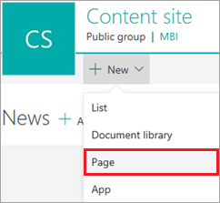

1. Enter a name for the page, like "Project Analysis".
2. Click or tap Plus icon. then **Power BI**.

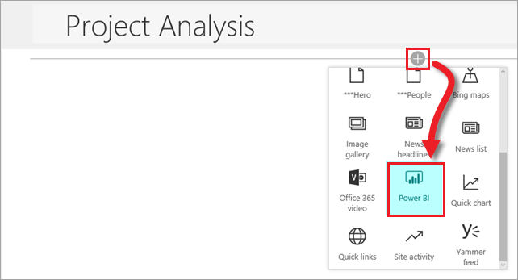

1. Click or tap **Add report**.

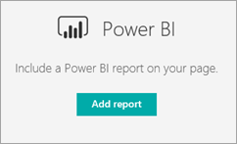

1. In the right pane, copy the embed URL into the **Power BI report link** box. Set both **Show Filter Pane** and **Show Navigation Pane** to **On**.

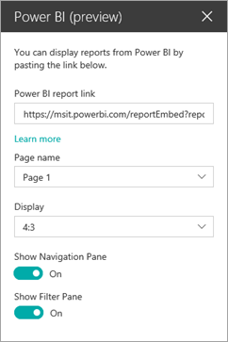

1. The report is now embedded in the page. Click **Publish** to make it available to anyone who can access the underlying report.

